VS Code (Visual Studio Code) – Installation

To get more information about VS Code check the provided power point presentation

**Perform this lab and provide full desktop screen shots and comment each screen shot. Provide a final summary as to time taken and issues and fixes you may have encountered.**

**Step 1:** Click the link to download VS Code <https://code.visualstudio.com/download>   
Select the version you want to download Windows, Linux or macOS. For Windows, choose the local installation of User Installer that does not require Administrator credentials for users on a system

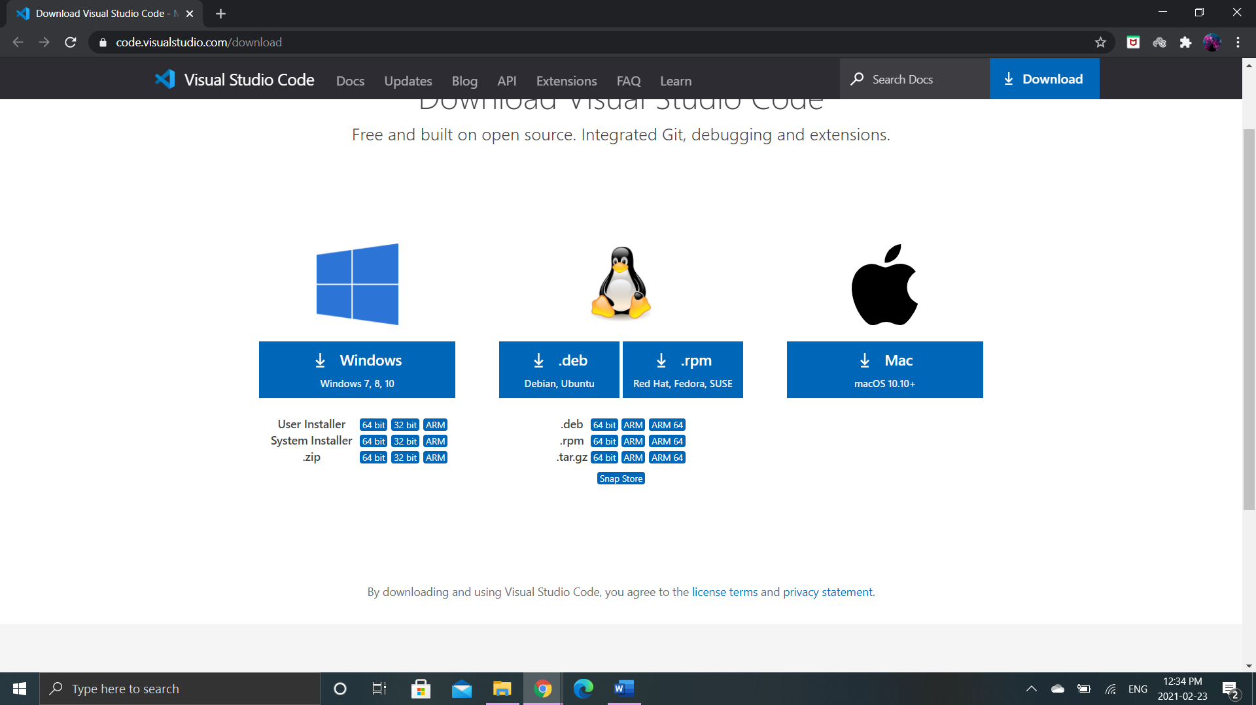

**Step 2:** Once the download is started, a new window will appear. Select “I accept the agreement” then hit the next button as shown in the figure below.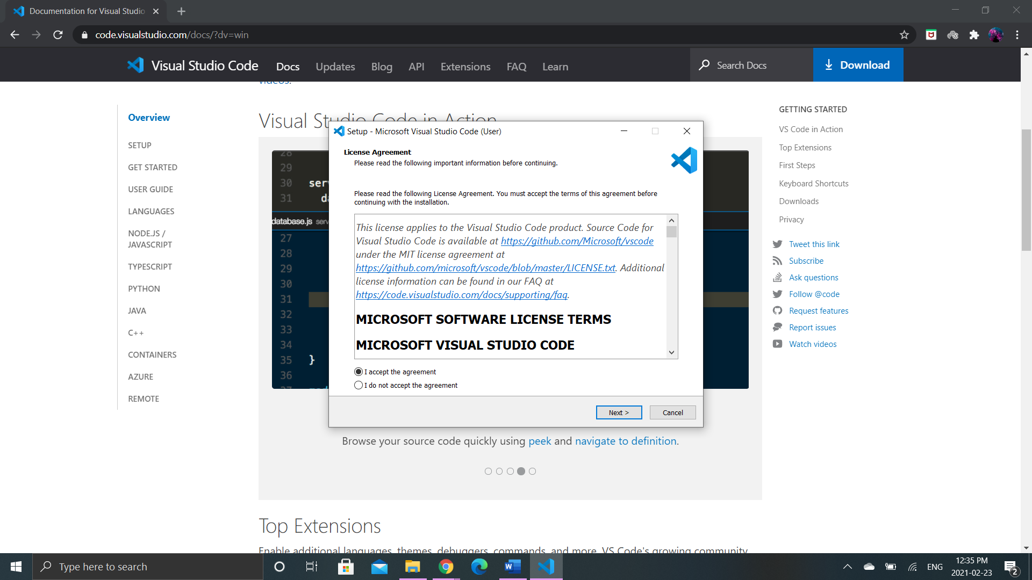

**Step 3:** Select the destination location to specify that where should the VS Code would be installed. Click on the browse button to select the destination path then hit next.

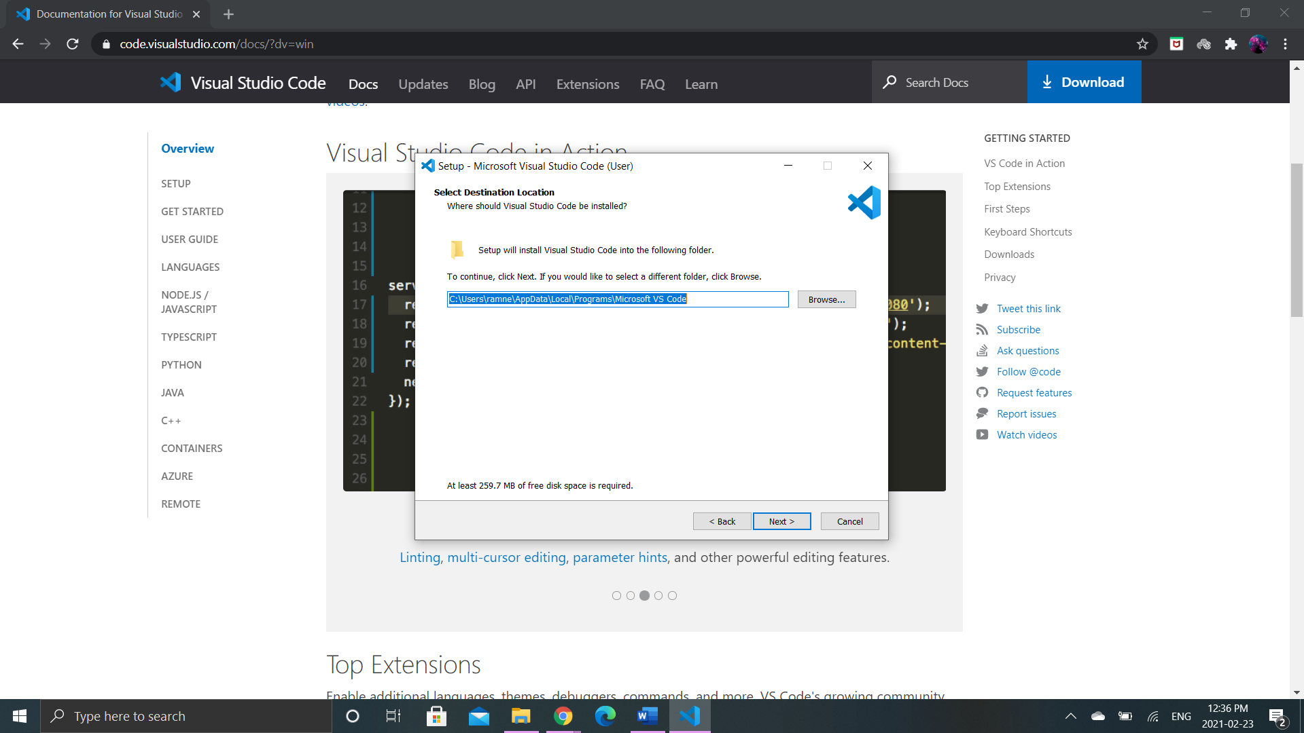

After you hit the browse button the window will appear as follows. Select the desired path and click ok.

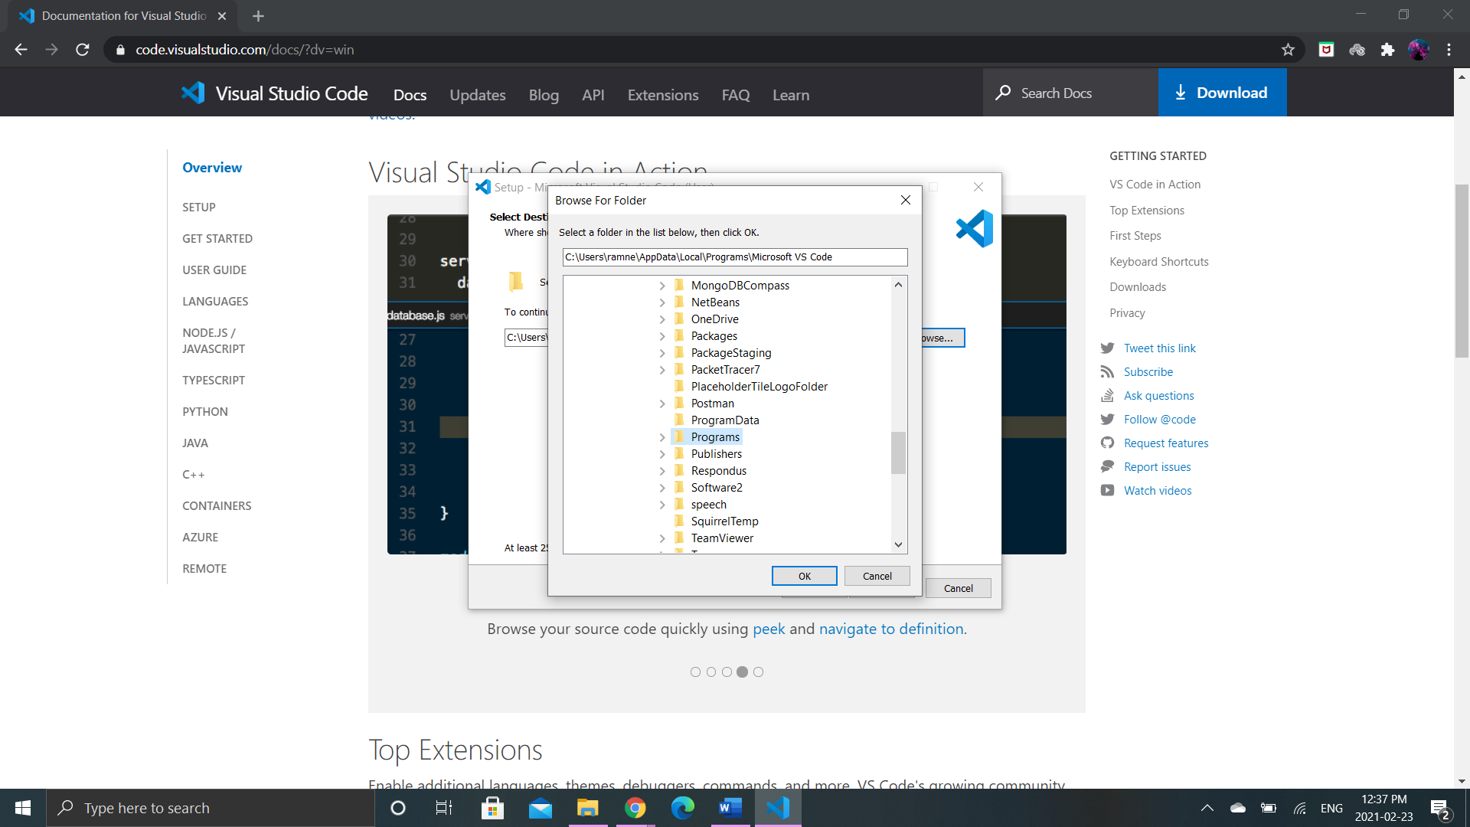

**Step 4:** Once the Selection of desired path is done the next step is to select the start menu folder which ask you the folder where setup will create the program’s shortcuts. Click on browse to select folder and hit next button.

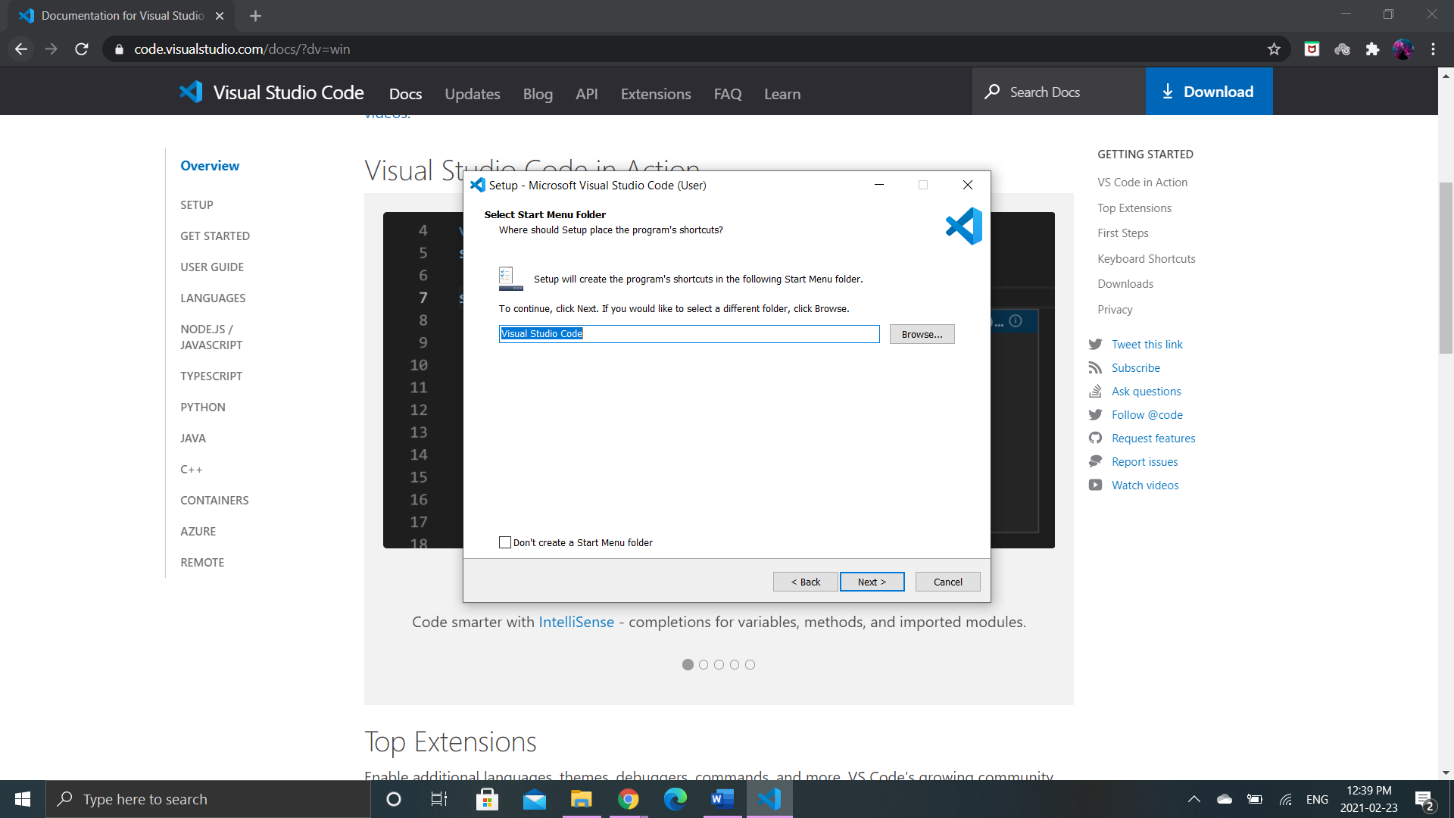

**Step 5:** It will ask for the additional tasks to setup while installing VS Code. Check the boxes that you want additionally for VS Code, Hit next button

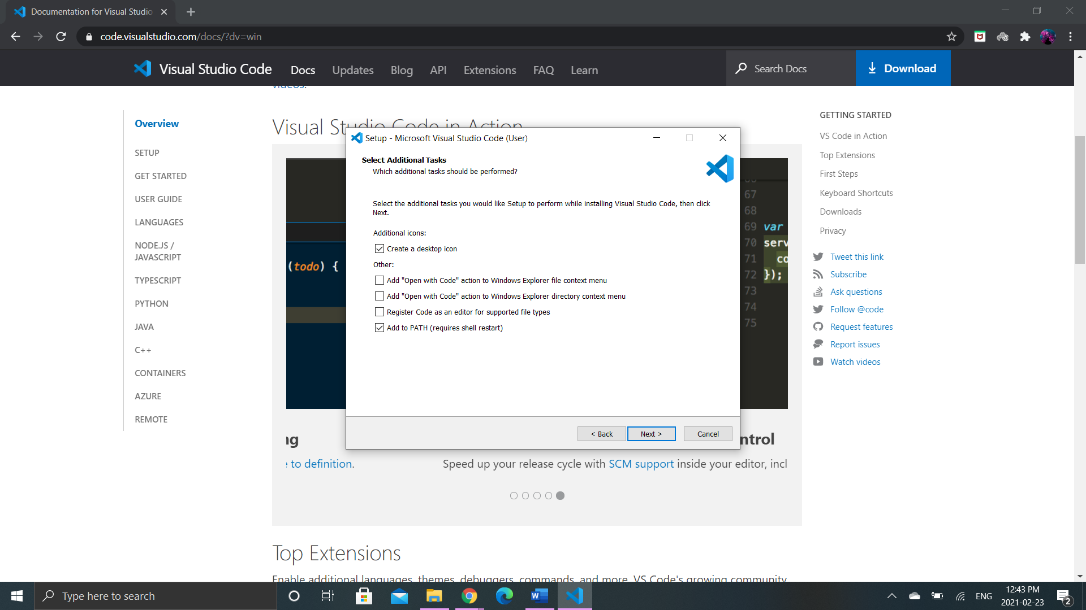

**Step 6:** Click Install Button to install the Visual Studio Code.

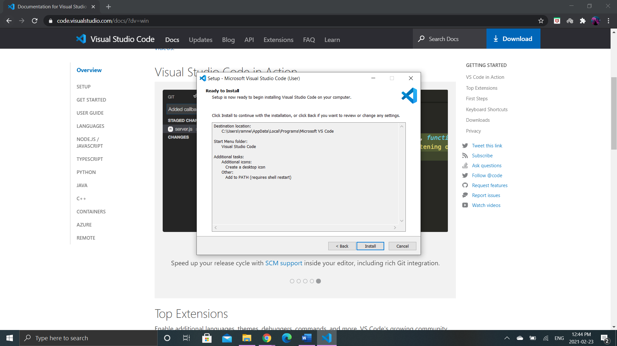

**Step 7:** Installation in progress. It will take few minutes or seconds to install.

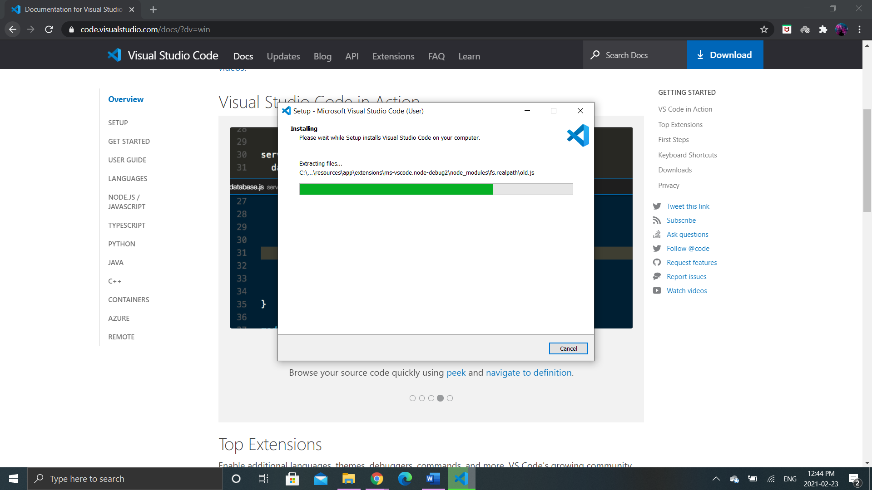

**Step 8:** Once the installation is done, click finish and open VS Code

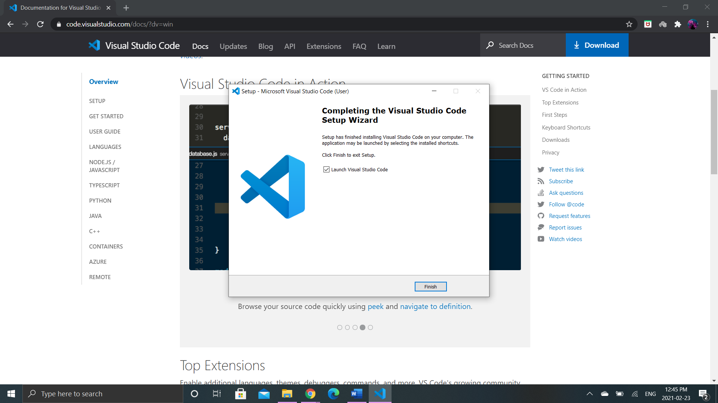

Main page of Visual Studio Code

